Graphical User Interface (GUI)

GUI (Graphical User Interface) in Java is an easy-to-use visual experience builder for Java applications. It is mainly made of graphical components like buttons, labels, windows, etc. through which the user can interact with an application. GUI plays an important role to build easy interfaces for Java applications.

Question #1

Using Microsoft word, write a paper of 2–3 pages, not including reference page to address the following questions in your response:

Using the library, the Internet, and your text materials, research the history of GUI in Java, and discuss at least 2 different technologies that can be used to create a GUI.

Be sure to cite all of your sources using APA format.

This assignment demonstrates your understanding of GUI in Java language.

GUI stands for Graphical User Interface, a term used not only in Java but in all programming languages that support the development of GUIs. A program's graphical user interface presents an easy-to-use visual display to the user. It is made up of graphical components (e.g., buttons, labels, windows) through which the user can interact with the page or application.
To make graphical user interfaces in Java, use either Swing (older applications) or JavaFX.
A GUI includes a range of user interface elements — which just means all the elements that display when you are working in an application. These can include:
- Input controls such as buttons, dropdown lists, checkboxes, and text fields.
- Informational elements such as labels, banners, icons, or notification dialogs.
- Navigational elements, including sidebars, breadcrumbs, and menus.
- Java has included Swing, an API for creating GUIs, in its Java Standard Edition since Java 1.2, or 2007. It's designed with a modular architecture so that elements are easily plug-and-play and can be customized. It has long been the API of choice for Java developers when creating GUIs.
- JavaFX has also been around a long time — Sun Microsystems, which owned Java before the current owner Oracle, released the first version in 2008, but it didn't really gain traction until Oracle purchased Java from Sun.
- Oracle's intention is to eventually replace Swing with JavaFX. Java 8, released in 2014, was the first release to include JavaFX in the core distribution.
- If you are new to Java, you should learn JavaFX rather than Swing, although you may need to understand Swing because so many applications incorporate it, and so many developers are still actively using it.
- JavaFX features an entirely different set of graphic components as well as a new terminology and has many features that interface with web programming, such as support for Cascading Style Sheets (CSS), a web component for embedding a web page inside an FX application, and the functionality to play web multimedia content.

If you're an application developer, you need to consider not only the tools and programming widgets you will use to create your GUI, but also be aware of the user and how he will interact with the application.
For example, is the application intuitive and easy to navigate? Can your user find what he needs in the expected places? Be consistent and predictable about where you place things — for instance, users are familiar with navigational elements on top menu bars or left sidebars. Adding navigation in a right sidebar or on the bottom will only make the user experience more difficult.
Other issues might include the availability and power of any search mechanism, the behavior of the application when an error occurs, and, of course, the general aesthetics of the application.
Usability is a field in and of itself, but once you have mastered the tools for creating GUIs, learn the basics of usability to ensure that your application has a look-and-feel that will make it attractive and useful to its users.
The most basic GUI elements you will be dealing with in Java include what are known as containers and components. A container is used to store the items the user will see on display, such as a panel or a frame (main window). These are the very core of what holds everything together and are the primary skeletal system of the GUI as a whole.
Components can be described as the add-ons or extensions to the containers that help to fill in the content and make up the rest of the user interface. Examples can include things such as a textbox, a button, a checkbox, or even a simple label. When you combine both containers and components, you begin to understand the bigger picture of what the GUI is and why it represents the core of the user experience for any program or application.
The GUI in Java can be broken down into two separate classes known as the Abstract Window Toolkit (AWT) and Swing. The Abstract Window Toolkit is the older of the two and is mostly the set of tools or programs that give a programmer the ability to create the components of the GUI itself, such as the buttons or scroll bars. They are known as the heavyweight components and are explicitly bound by the platform or operating system they are being used on.
Swing can be described as the newest form of the two, doing the same thing as AWT, but as extensions to the AWT itself. These are known as the lightweight components and are entirely independent of the platform or operating system, which give them much more freedom and flexibility than the AWT. Without these tools in place, it would not be possible to create anything relating to the GUI, which makes these tools the origin or starting point of what makes the elements of the user interface become a reality.

WorkCited
Leahy, Paul. (2021, February 16). Developing a Java GUI. Retrieved from https://www.thoughtco.com/gui-2034108

GUI Components in Java: Definition & Examples. (2017, November 27). Retrieved from https://study.com/academy/lesson/gui-components-in-java-definition-examples.html

Question #2

From your hw9, select one of the two questions that you have completed and apply Java GUI features in the program. You must at least apply three Java GUI features – GUI data input windows, GUI data output windows, and pick one more of the Java features such Buttons, Event-Drive feature, Scrollable GUI, or other Java GUI related gadgets. You can also implement JavaFX features.

Demonstrate in your program that you understand how to apply the implement Java GUI features in your program. The assignment’s points will be determined by how much Java GUI features you have applied in you program.

Submit your program and your program output to the class backboard. Please include at least three output displays with different test values.

Write a Learning Report Summary (LRS)

Using Microsoft Word, write a summary report (not a bullet items) with a minimum of 100 words explaining how you completed your assignment. Please describe your responses, not just yes/no answers.

- Did you successfully get your assignment done? Did it run? Any error? Did you get the correct result? Did you test your program thoroughly?

Yes, I have completed the assignment and it runs without any errors.

- How much time did you spend to complete your assignment?

I have spent 4 hours on this assignment.

- Did you find the assignment easy or challenging for you?

I felt he assignment challenging to me.

- Did you write the program yourself? Did you get any help from anyone?

I wrote the program myself without getting help from anyone.

- When you encountered obstacles to complete your program, how did you resolve the issues? Did you use Google to get help? Describe how Google was abled or not able to assist you?

Whenever I get suck, I referred to lecture notes and that helped me resolve any issues I had.

- What did you learn from doing this assignment?

I learned the use of GUI in Java, Java features like Buttons, Event-Drive feature, Scrollable GUI and also how to implement JavaFX features.

- Any other information you would like to share with your instructor? Make sure you provide program output on each option.

The mouse option not working, I had to use keyboard tab, down key to choose my options.

What to submit

- Your program source code listing.

- Your program output.

- Your research papers.

- Your LRS.

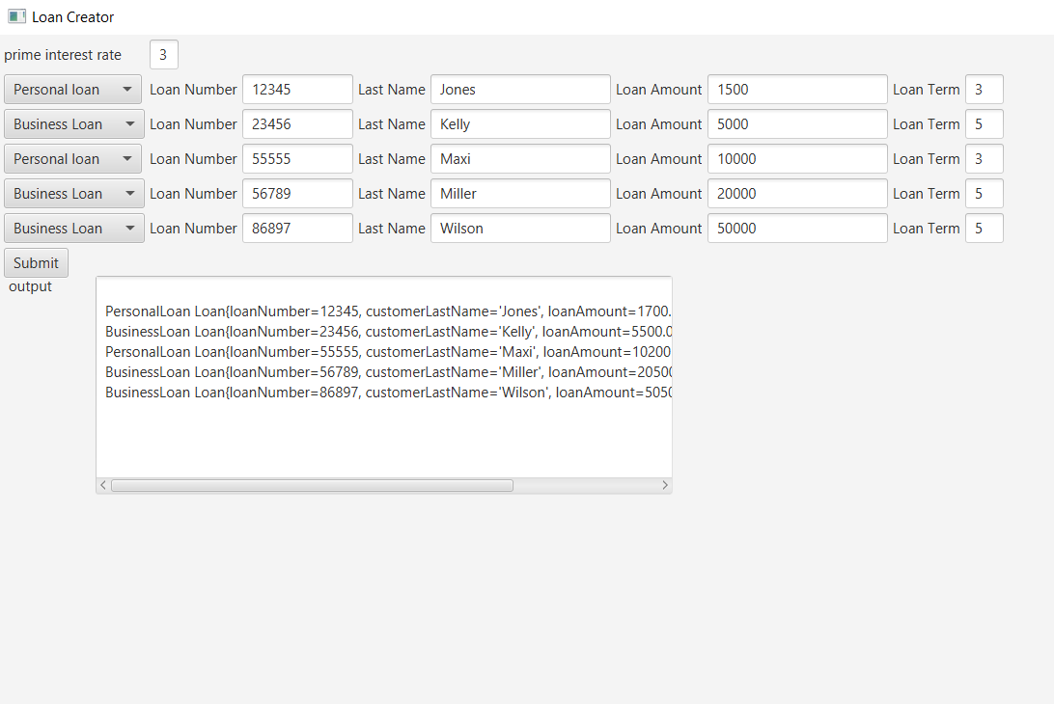

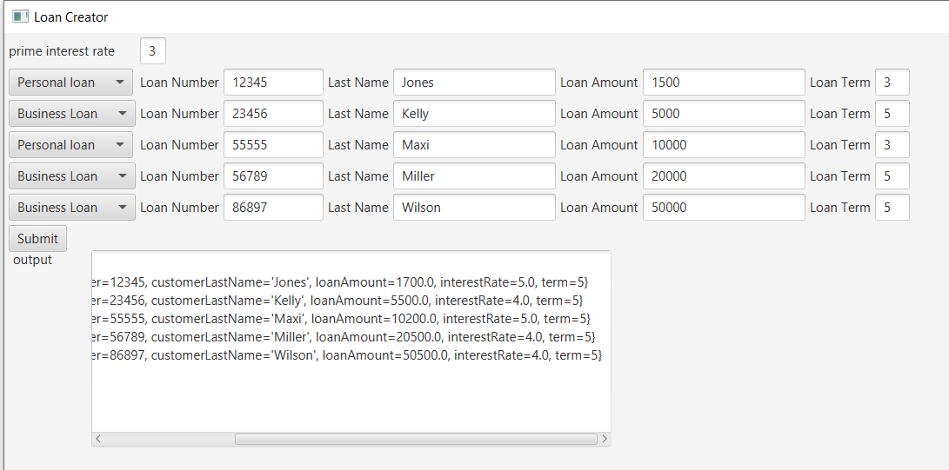

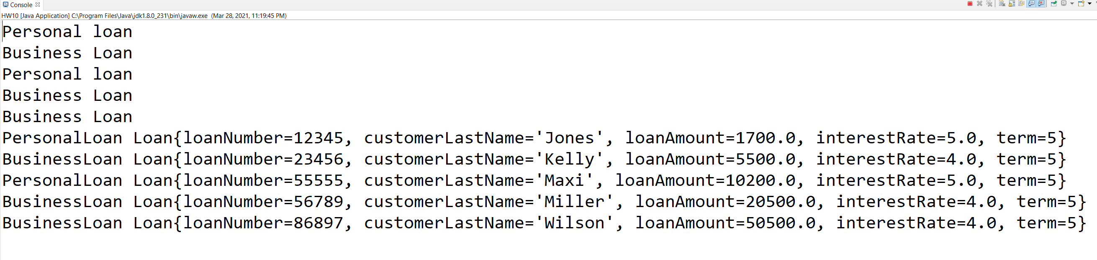

2

